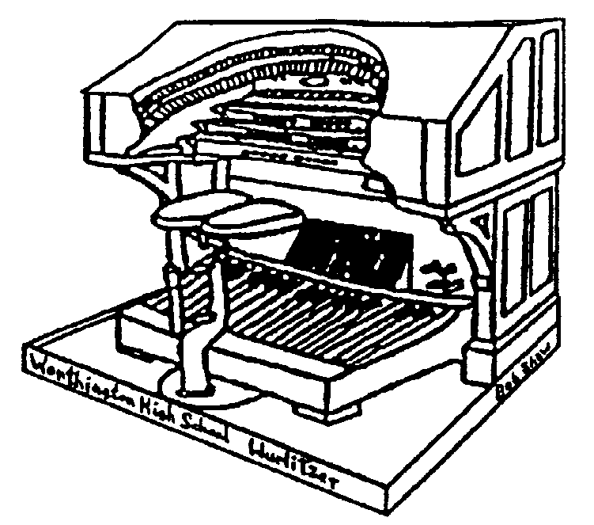THE STOPTAB

THE OFFICIAL NEWSLETTER OF THE

CENTRAL OHIO THEATRE ORGAN SOCIETY

September 2005 Mark Williams, Editor
markwilliams@ctcn.net

RETURN TO THE OHIO THEATRE

COTOS will meet at the Ohio Theatre, Sunday, September 18, 2005 at 3:00 PM.
Directions: From North Columbus take I-71 South to Spring Street exit.(left lane of freeway to exit). Go West on Spring Street to Third Street. Turn left and follow to State Street. Find parking. You will be entering the theatre using the side entrance in the Galbreth Pavillion. FROM Points SOUTH:From I-70 use the High Street exit. Go north on High Street Street to State Street. Find parking and follow entrance instructions above. The doors will open about 2:45 PM. For this meeting there will be NO FOOD.

Guests at COTOS Meetings

Just a reminder about the new policy of guests at our COTOS meetings. If a member brings a guest who is a potential member, that member gets to choose a CD from among those the club has available. Then if that guest joins COTOS, the guest also gets to pick out a CD.

UPCOMING MEETINGS….

October – Home of Dr. Karl Saunders, Zanesville, Ohio
November – Home of David and Mary Geiger
December – Christmas Potluck at Tom and Ann Hamilton’s home

President’s Corner…

I want to thank everyone for the great turn out at Betty Posley’s. All together there were 28 members alng with guests. Mark Williams was the guest organist with numerous members and guests also playing while the rest of us ate some great food (with NASCAR being shown on the big screen).

Over the last month COTOS has received several donations from members. Donated money will be used for rebuilding and maintenance of the Wurlitzer. We have several projects in mind. I want to say THANK YOU to all who have contributed at this time.

Central Ohio is getting a new theatre organ on the west side. Jubilee 2000 located at the Holy Family Parish has acquired a Kilgen theatre organ (2/4 opus 4049). As of now they are planing to rebuild this instrument with technical assistance from Peebles-Herzog Inc. As I hear more I’ll update everyone.

Come all, Came all – this month’s meeting is at the Ohio Theatre. We are to use the side entrance in the Galbreth Pavillion. Doors open about 2:45. Tom Hamilton is our guest organist. Then after there will be open console on the Mighty Morton 4/34. See you all there. Duane King

Help with COTOS finances and earn free CD’s

Expenses associated with the installation of the Z-tronics system are running more than expected. The system requires a number of pistons which are up to us to order. In addition, the sequencer, which allows us to record the organist’s finger motions, is now obsolete, with an entirely new system being designed. This in itself will require roughly $700 in unexpected expenses.

To meet these requirements, COTOS is encouraging members and friends to donate to this cause. As appreciation for the donations, COTOS will allow each donor to pick CD’s from the COTOS collection of organ concerts. One CD for each gift of $125, or ten CDs for a gift of $1,000. These CD’s are not available from anywhere else and include many concerts at the Ohio Theatre from 1967 on, including concerts by Bill Dalton, Roger Garrett and many more. At the moment there are about twenty to choose from, but the list is growing as more concerts are converted from reel-to-reel tapes to CD’s.

Tom Hamilton is organizing this operation and has the CD’s for your selection. You may contact him by phone at 614-486-6043, or by e-mail at TOMKH@EARTHLINK.NET. He will not be at the July meeting as he will be on vacation from July 16-31.

Tom K. Hamilton

PLAYING BY EAR – Part 1… by John Adams

Many people think that anyone who plays by ear can’t read music. Sometimes that is so but no always. To me it means being able to pick out a melody without the written music. You don’t have to have perfect pitch to do that but neither should you be absolutely tone deaf. The first would mean being able to play any note right the first time and the second would mean, getting it right would be like playing the lottery – pretty doubtful. If you can’t do that very important but simple step then the following instructions will be very frustrating. Equally important would be being able to add an appropriate left hand accompaniment, a chord, simple as it may be. A chord is 2 or more notes that sound pretty good together and played with one hand. Less than two notes is not a chord – with me so far? Not the best definition but it’s true. If a chord is broken it means it is played like a short arpeggio (kind of a odd definition, not like “broke”). Usually the melody is played with the right hand and the accompaniment with the left. Sounds better that way because the notes to the right are higher pitched and easier to listen to and recogi\nize. I read recently that the main reason that the lower notes are to your left on a keyboard is because the early mechanical (tracker) organs were built with the bigger pipes to the left. I don’t know how accurate that is.

The right hand is going to be playing at least one note at a time. Any less is going to be pretty boring (unison off?) You can play more than one but don’t try that yet. It is very importan to start your tune on the correct note or else you may wind up playing in some key with far too many black notes. Generally speaking, but not always, if you start on C for instance the key will be C which has no black keys (sharps or flats) to fool with and believe you me, life will be much easier. If I had my way there would be no black keys.

Before going further, perhaps you may wonder why an octave – A to G for instance – has 12 notes since from first grade we are told that “octae” come from the Latin word “octava” meaning eight. OK, so you didin’t learn that until second grad. You may think then tat a – G should be called a twelfth or zwelif for the Old English among us. Not so, although occasionally in Organ stops the term “twelfth” is used. And it is actually an octave higher. There are however eight white or whole notes before repeating hence the octave business. It might be good to say at this point that since the note names repeat every eight notes – tha is A to A to A etc., then you may or may not realize that for every octave the frequency of a particular note doubles or halves depending on which way you are headed. This is of little importance unless you are tuning a piano or organ. Speaking of frequency, modern day tuning is to tune the A above middle C at 440 cycles per second (cps). Therefore the A above that one would be 880 cps and the one below would be 220 cps. Some really smart group of people a few years back thought “cycles per second” was too mundane and declared that henceforth we would say “Hertz” so say it that way if you want. Mr. Hertz apparently needed some overdue recognition. The organ by the way, has the widest frequency range of any instrument known to man or beast. This would not include electronic instruments which could theoretically be below and above the range of human hearing, but not beast.

From high school band to practice to Fake books … Part 2 will be continued in OCTOBER STOPTAB…

Please have all articles to the publisher by the 25th of each month for publication.
THE STOPTAB
c/o Mark Williams
236 New haven Dr.
Urbana, OH 43078
FIRST CLASS

THE STOPTAB is the official publication of the Central Ohio Theatre Organ Society, a member of the American Theatre Organ Society, Inc.. The Stoptab is published approximately monthly. The Publisher is Mark Williams, 236 New Haven Dr. Urbana, Ohio 43078.

CHANGE OF ADDRESS: Send old label and printed or typed new address to Mark Williams, 236 New Haven Dr., Urbana, OH 43078. E-mail address (when it works) is : markwilliams@ctcn.net.

