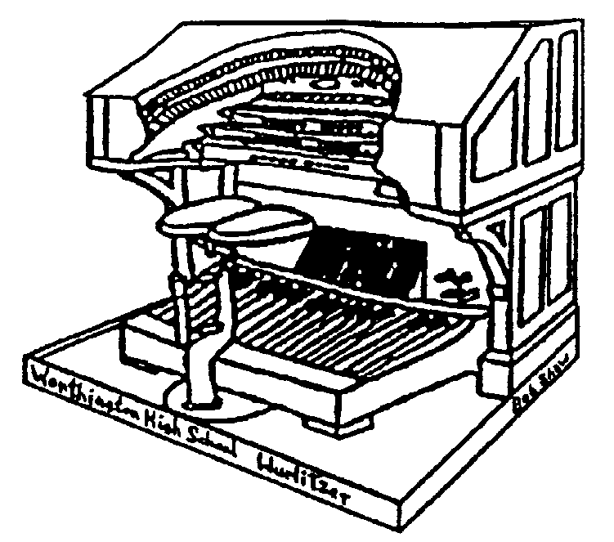THE STOPTAB

THE OFFICIAL NEWSLETTER OF THE

CENTRAL OHIO THEATRE ORGAN SOCIETY

October 2005 Mark Williams, Editor
markwilliams@ctcn.net

Zanesville Meeting October 16th

COTOS will meet at the home of Dr. & Mrs. Karl Saunders on Sunday, October 16th at 3:00 PM. The Saunders address is 360 Broadview, Zanesville Ohio.
Directions: From Columbus take I-70 East toward Wheeling. Continue eastbound to exit 154 (5th Street).Turn Left onto North 5th Street. Merge onto I-70 West via the ramp on the LEFT. Take the Maple Ave exit – Exit 153B. Stay straight to go onto MAPLE Ave. Follow Maple Ave. Make a slight RIGHT onto Dresden Rd. Follow Dresden Rd. Turn Right onto BROADVIEW Ave.

From Points North : It may be easier to take State Route 161 (Rte 16 in Newark) east Through Newark. Continue on 161 east until you find State Rte 146. Go South on 146 to Zanesville. Turn Left at Maple Ave. and follow the above directions to Broadview Ave. (Estimated Mapquest time via the I-70 Route is 1 hour and 13 minutes - roughly 66 miles from north Columbus locations).

Guests at COTOS Meetings

Just a reminder about the new policy of guests at our COTOS meetings. If a member brings a guest who is a potential member, that member gets to choose a CD from among those the club has available. Then if that guest joins COTOS, the guest also gets to pick out a CD.

UPCOMING MEETINGS….

November – Home of David and Mary Geiger
December – Christmas Potluck at Tom and Ann Hamilton’s home
From the President…

Update on the Z-Tronics system. All ranks and tuned percussions in the main chamber have terminated on their individual driver boards. All new power has been run to each rank back to the driver board.

All tuned percussions (except piano), traps, tremulants and shades have been terminated to their proper diriver board and new power lines have been run. Both chambers are 99% done. Most of our work is now in the console. When the console is completely wired we will permanently run the final connections to the chambers from the console. We will be starting the console work by meeting time.

Down at Capital University, dedication was held for their new 3 manual, 70 rank Schantz organ. The evening was filled with 6 different organists (most with a PHD). The events started with Jan Linker playing along with the Capital Brass to theatre organ music (yes there are theatre ranks), to hymns sung along with the choir and organ; to the last piece “Toccata from Symphony No. 5” which brought out what this organ has to offer. An audience of almost 900 provided a standing ovation. If you ever have an opportunity to hear this instrument it would be well advised to do so.

Our meeting at the Ohio Theatre last month had a large turn out with several new faces, I feel we all had a great time. A lot of great music was played by several organists. Plus som childhood memories of my own when Tom Hamilton and Jan Linker sat down at the Mighty Morton to play. Speaking about Tom, he has made a DVD of the event, which is available to anyone who makes a $13 donation to the Restoration fund. We will have order forms at the monthly meeting.

One last item – if anyone wants to come to Worthington to see what we have installed and to learn how the Z-Tronics system works, the organ crew is working every Saturday from 9:30 AM to 5:00 PM (and possibly 9:00 pm). Just drive around to the back and end go in the blue double doors. There are other times we are there through the week and sometimes on Sundays. Feel free ot call me at 614-306-0349 or 740-967-3645 to find out exact times. Duane

Available for purchase…

At the October 16th meeting, the following items will be available for purchase, money going into the organ maintenance fund:

- A copy of the DVD of the September meeting at the Ohio Theatre. The DVD has a menu so you can go directly to any of the persons who played. (4 available at $13 each)
- A color Xerox copy on heavy stock of Roger Garrett’s personal copy of the music to “Romance.” The cover is stamped with his name, and contains penciled notes by the publisher as to where Roger’s picture is to be placed. (8 copies available at $6 each)
- A Xerox copy on heavy stock of the music “Caprice Viennois” (The Moon River Theme) which was hand written by Lee Erwin for Tom Hamilton. (4 available at $6 each)

PLAYING BY EAR – Part 2… by John Adams

Some folks look down on people who can only play by ear. Some people who can’t play a lick, look u to them. For me, it beats not playing at all, but I surely wish now that I had taken more than two years of piano when I was about two bricks high. My Dad said that if I wasn’t going to practice he wasn’t going to waste his money. This, as it turned out, was not a wise approach. I seemed to have promptly forgotten the little bit I learned when I was told I didn’t have to take any more lessons. (on a personal “note”, at 77, I am really trying to read the notes and have tackled some very simply written classical pieces and it is more fun than when I was ten years old, as best as I remember).

Later in high school after getting involved in band (tuba), I became interested in playing the piano again. Some of my buddies and I would on occasion get up a little combo for some specific function. I wound up playing on occasion the accordion, the trombone and probably spoons, whatever was necessary. Late on e night while listening to my bedside radio I heard this advertisement for a “play by ear” course by Dave Minor. I sent in the $1.49 for the one book course. The rest is history although not significant history. This little book with big notes taught a few chords and simple melodies and how to put them pleasingly together. It didn’t however describe how the chords were formed but what do you expect for $1.49 plus postage? Once I discovered how to form any chord in any key, sometime on the run, it became much more fun. Dave only wrote his music in the key of F as I remember. Anyway, that was the only key I played in for a long time.

All songs are written in some key, like F for example. The key of F has a B flat (black) which is easier for me for some reason than C which is all white keys. I personally think that anyone who can pick out a tune with one finger could then learn the few chords to go with the tune and be on his or her way to success on the stage – maybe the one to Black Rock. Of course, you also need to know how to count. For instance, the C major is C, E and G. Now that wasn’t so hard was it? These are just some simple examples. To make a minor chord, like Cm, lower the 3rd key in the chord a half step. Lower is to the left in case you wondered. The pointer system, not the Pointer Sisters, also works. In this method, point your index finger at the note of choice, C for instance, put your thumb on the 3rd note up from C (to the right) and your little pinkie on the 4th note down from C (left) and you also get the major chord. This works to form the major chord in any key. Ain’t that neat?

The book of choice for playing by ear is the fake book. The fake books, with literally thousands of songs, melody only and chord names, were published originally for night club performers for a quick reference and were for a long time illegal because of copy right laws. Now they are mysteriously legan and can keep you busy for hours at a time and out of trouble otherwise. All of this should inspire you to hop to your piano or ofgan and whip out a simple tune. With today’s really inexpensive keyboards, if you don’t have a piano or organ handy, anyone could at least attempt this approach and it’s better than not playing at all. As a post script, strangely, many people who play very well, know nothing about chords and how they are formed although examining written music very carefully, you will see that the chords are there though seldom identified. – John Adams.

Please have all articles to the publisher by the 25th of each month for publication.
THE STOPTAB
c/o Mark Williams
236 New haven Dr.
Urbana, OH 43078
FIRST CLASS

THE STOPTAB is the official publication of the Central Ohio Theatre Organ Society, a member of the American Theatre Organ Society, Inc.. The Stoptab is published approximately monthly. The Publisher is Mark Williams, 236 New Haven Dr. Urbana, Ohio 43078.

CHANGE OF ADDRESS: Send old label and printed or typed new address to Mark Williams, 236 New Haven Dr., Urbana, OH 43078. E-mail address (when it works) is : markwilliams@ctcn.net.

