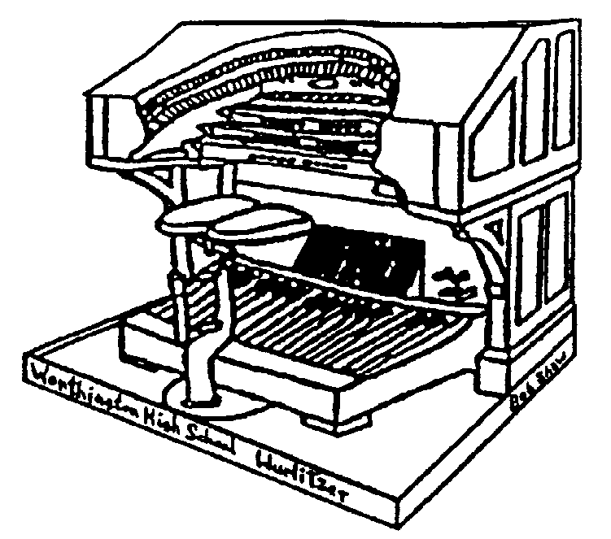THE STOPTAB

THE OFFICIAL NEWSLETTER OF THE

CENTRAL OHIO THEATRE ORGAN SOCIETY

November 2005 Mark Williams, Editor
markwilliams@ctcn.net

November 20th meeting in Westerville

COTOS will meet at the home of Dave and Mary Kay Geiger on Sunday, Novembe 20th at 3:00 PM. This is the first time COTOS has visited the Geiger's new home in Westerville. The Geiger’s address is 471 North Church Lane.

Directions: From Columbus Take I-270 to the Cleveland Ave. exit. Go north on Cleveland Avenue to County Line Road (This is north of Main Street). Make a right (east) on County Line Road and continue past State Route 3 (Westerville Road). After you pass Otterbein Avenue, look for Belle Haven Parkway (2nd street on left). Turn Left on Belle Haven and proceed to North Church Lane (4th street on the left). Make a left on North Church and look for 471 on the left hand (south) side of the street. Finger foods and snacks will be the fare for the afternoon

The organ is a 2/9 Wurlitzer, essentially a merger of two Wurlitzers, one 5-ranks and the other 4-ranks. Two duplicated ranks were replaced by a clarinet and orchestral oboe. Tuned percussions and swell shades are functional. The Console is a two manual Wurlitzer installed in a newly finished basement room. When asked "What would you ever do if you wanted to move?" Dave responded “Well, you reduce it to little pieces, and make a lot of trips with a minivan.”

COTOS is sad to learn of the passing of William Hadler in October. William enjoyed the music and supported our efforts to restore the Wurlitzer. Our thoughts and prayers are with Dottie and the Hadler family

UPCOMING MEETINGS….

December – Christmas Potluck at Tom and Ann Hamilton’s home
DUES: Due by December 31 – A form will be in next month’s issue!
THE STOPTAB
c/o Mark Williams
236 New haven Dr.
Urbana, OH 43078
FIRST CLASS

THE STOPTAB is the official publication of the Central Ohio Theatre Organ Society, a member of the American Theatre Organ Society, Inc.. The Stoptab is published approximately monthly. The Publisher is Mark Williams, 236 New Haven Dr. Urbana, Ohio 43078.

CHANGE OF ADDRESS: Send old label and printed or typed new address to Mark Williams, 236 New Haven Dr., Urbana, OH 43078. E-mail address (when it works) is : markwilliams@ctcn.net.

