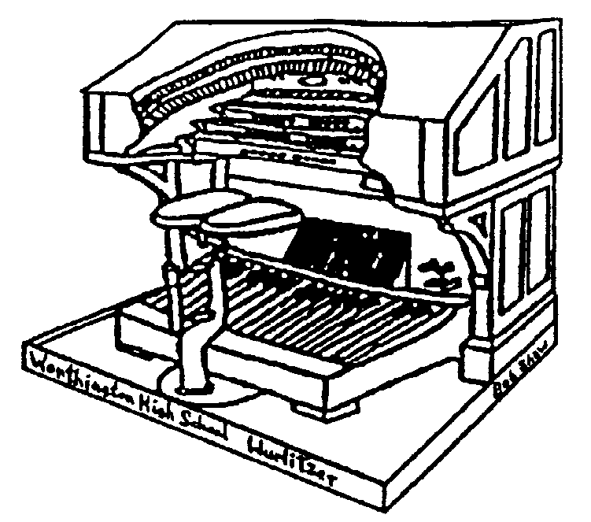THE STOPTAB

THE OFFICIAL NEWSLETTER OF THE

CENTRAL OHIO THEATRE ORGAN SOCIETY

June 2005 Mark Williams, Editor
markwilliams@ctcn.net

June 19th Meeting at Baltic

The June 19th meeting of COTOS will be held at the residence of Dorothy Steiner in Baltic, Ohio. Dorothy has a 3/16 Wurlitzer, which has been built up over the years from a smaller original instrument, Wurlitzer Opus 1684, a Style B. Also featured are a Conn and Hammond organ, and a collection of antique cars. The meeting will begin at 3 PM. Covered dishes and finger foods are also welcomed.

Directions: From Columbus: Take Interstate 70 EAST to I-77 (Cambridge, Oh). Go North onto I-77 to Newcomerstown (St Rte. 36). Exit WEST onto Route 36 and go about 11 miles, where you with turn right (North) Onto Route 93. From this point it is about another 11 miles to Baltic, OH. Turn Right at the flashing light, which is MAIN STREET in Baltic. This is also CR46 as you head out of town. You will go over a hill, and there will be a schoolhouse on the left. The next house on the left is Mrs. Steiner’s. Proceed past her dirveway to the next drive, which is the parking lot.

Guests at COTOS Meetings

Just a reminder about the new policy of guests at our COTOS meetings. If a member brings a guest which is a potential member, that member gets to choose a CD from among those the club has available. Then if that guest joins COTOS, the guest also gets to pick out a CD.

These CD’s are not available anywhere but from COTOS and include many of the Ohio Theatre Organ Concerts produced by HBG Enterprises.

Selections include but not limited to:
1972 Bill Dalton at Ohio Thjeatre, 1970 George Wright at Ohio Theatre and 1970 Tony Fenelon at Ohio Theatre. Please bring your potential members and collect your reward. Tom Hamilton
UPCOMING MEETINGS….

July 17 – Strand Theatre, Delaware, Ohio

PRESIDENTS MESSAGE…

We are giving away music to any COTOS member that brings a guest that has never been a COTOS member. If the guest does join, they will also receive a free theatre organ CD of their choice. There are three different CD’s to choose from.

They are: 1) Tony Fenlon – (1970) at the Robert – Morton Ohio Theatre; 2) George Wright – (11/70) at the Robert -Morton Ohio Theatre and 3) Bill Dalton – (11/72) at the Robert-Morton Ohio Theatre.

All three CD’s are excellent recordings, all recorded by HBG Enterprises.

Year 2006 spring concerts are in the works. We are currently talking with Bob Ralston to be the first artist in several years. Also we are talking about bringing back silent films to the school kids. Everyone feels that getting our Wrulitzer back out in the public’s eyes will help generate new members.

If anyone wants to help with getting our spring concerts together, PLEASE let anyone on the board know.

At the time I was writing this message, the first shipment of the Z-Tronics relay system came in. If anyone wants to give us a hand installing our new relay system, PLEASE give anyone on the board a call. This will insure our Wurlitzer is up and playing 100% by December. This goal is very realistic with extra help.

Sincerely,
Duane King

COMING NEXT MONTH…

The Virtual Organ – contributed by John Adams

Is it organ or is it computer?????

Read about it next month in STOPTAB
FINANCIAL REPORT FOR THE 2004 CALENDAR YEAR (as filed with the Ohio Attorney Generals’ office, May 2005) – this report includes all assets of COTOS

Beginning Balance (1/1/03) $ 68,931.32

INCOME:

Contributions/gifts/grants 267.00
Program Revenue 0.00
Membership dues 1236.00
Interest (checking/savings) 236.68
Tape / CD sales 0.00

TOTAL REVENUE $ 1739.68

EXPENSES:

Wurlitzer / Conn 650 expense 6844.55
Insurance 538.00
State Fees / Taxes 50.00
Postage 259.00
Printing/Office Supplies 169.30
Misc. Expense 40.00

TOTAL EXPENSES $ 7900.85

ASSETS:

1926 Wurlitzer Pipe Organ 42,500.00
Conn Model 650 Electronic Organ 5,000.00
Inventories for Sale 600.00

TOTAL (non-cash) ASSETS 48,100.00

CASH ASSETS:

Checking Account $ 2892.52
Savings Account 11877.63

TOTAL CASH 14770.15

TOTAL COTOS ASSETS 12-31-04 $ 62,870.15

Respectfully,
Mark Williams, Treasurer, COTOS
06 MAY 05

THE STOPTAB
c/o Mark Williams
236 New haven Dr.
Urbana, OH 43078
FIRST CLASS

THE STOPTAB is the official publication of the Central Ohio Theatre Organ Society, a member of the American Theatre Organ Society, Inc.. The Stoptab is published approximately monthly. The Publisher is Mark Williams, 236 New Haven Dr. Urbana, Ohio 43078.

CHANGE OF ADDRESS: Send old label and printed or typed new address to Mark Williams, 236 New Haven Dr., Urbana, OH 43078. E-mail address (when it works) is : markwilliams@ctcn.net.

