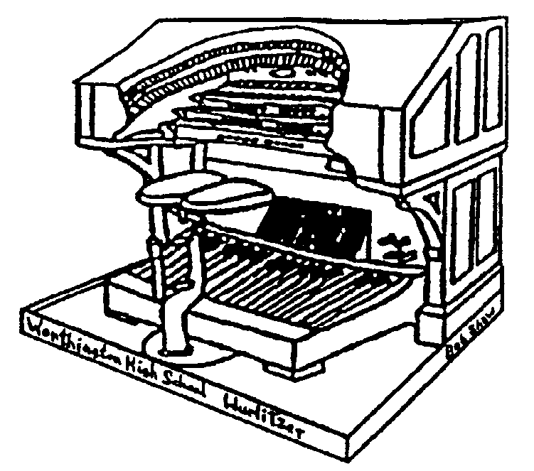THE STOPTAB

THE OFFICIAL NEWSLETTER OF THE

CENTRAL OHIO THEATRE ORGAN SOCIETY

July 2005 Mark Williams, Editor
markwilliams@ctcn.net

July 17th Meeting at Strand Theatre, Delaware, Ohio

The July 17th meeting of COTOS will be held at the Strand Theatre, 28 E. Winter Street, Delaware Ohio. The meeting will begin at 3:00 PM. Featured will be the chapter’s Conn 650 Electronic Theatre organ with added chimes and speakers.

Directions: From Columbus: Take State Route 23 North to Delaware. Exit Route 23 at the US-36 / William Street exit (also is the US Route 42 ramp toward US Route 37). Turn Left unto US Route 36 (William Street) and continue west to North Union Street. Turn right (North) on North Union Street and go about 0.1 miles to East Winter Street. Turn Left (west) on East Winter Street and the theatre will be on the Left. Follow parking directions for the street or parking lots. Phone number to the theatre is (740) 363-4914.

Guests at COTOS Meetings

Just a reminder about the new policy of guests at our COTOS meetings. If a member brings a guest who is a potential member, that member gets to choose a CD from among those the club has available. Then if that guest joins COTOS, the guest also gets to pick out a CD.

UPCOMING MEETINGS….

August 21 – Annual Potluck at Betty Polsley’s home in Urbana, Ohio

The Virtual Organ

Submitted by John Adams

At first glance this topic may seem to have nothing at all to do either with COTOS or the Wurlitzer Style 260 pipe organ in Wrothington High School. But wait!.

Virtual, in this instance anyway, refers to an organ which is like, for lack of a better comparison, a virtual dictator, a virtual promise, a virtual storm of protest – not the real thing, not elected, not present, but very close to the real thing and very usable.

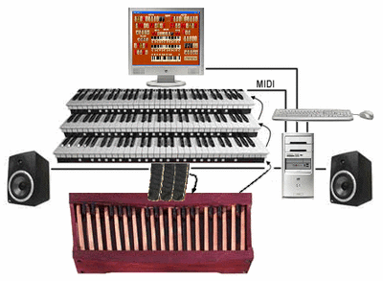
The Virtual Organ needs; 1) a personal computer; 2) one or more keyboards that can send MIDI messages and ofcourse; 3) some way to hear the sounds. All of the above can and do, in the real world, be of many configurations.

A MIDI message or code is merely that, a series of encoded commands to play a certain note, and send this information over two wires to a sound module for instance that actuall produces the sound. This code was agreed upon about 25 years ago so that musical instruments, primarily keyboards and sound modules, could have a common way to communicate with each other, no matter the manufacturer. For the Virtual Organ your computer beocmes the sound module.

The Virtual Organ needs a sound font (the pipes). Good sound fonts are those that have been assembled from real pipe sound samples, but they can be “created” by very clever people. Fortunately, for this type of organ, there are now very good fonts available for free on theinternet. Some are classical, a few are theatre and some of these are copies of actual Wurlitzer organs. For my own Virtual Organ I have two sets of theatre fonts, a 20 stop French classical, a very large European fictitious organ and an English organ. This might sound like overkill but I am experimenting.

So, if you already know all of this, are not interested in knowing any of this, cannot play a single note, don’t own a computer (you live in a cave??) then please proceed to THE END. Otherwise if I have piqued your curiosity then read on McDuff or was it Macbeth?

A gentleman in California has created an organ relay (virtual of course) that will control an organ. It is called the Miditzer and the organ console (the relay) is patterned after the Rialto organ George Wright used to play, a 10 rank, two chamber Wurlitzer. The sound fonts for this virtual organ were created (not sampled) by Bruce Miles of somewhere in the UK. The Miditzer console appears on your computer screen eerily like the real thing. It can even be played, sort of, from your computer keyboard. The stops are controlled by your mouse. (Whoever thought a mouse could be trained so well?)

Before you get too excited though as I’m sure you are by now, the Miditzer is by far the simplest of the various programs available, can be installed easily on your computer and will by itself play General Midi Files (a standard of 127 sounds or instruments). So don’t even think about trying out the various other schemes for now. The Cinema sound font though is necessary for the true theatre sound and to use those fonts a sound card such as Sound Blaster, which supports those type files is required. Mine is an external card which just plugs into a USB prot. To use a MIDI keyboard no, matter how small, requires an interface like the Midisport (by M-Audio) which basically adapt the MIDI plug to a USB plug, but all of this is quite doable. And to quiet the critics ahead of thime, this is not to replace real organs, but how many of you have a spot in your home for a large pipe organ or the money for that matter.

Think of it; someday you may, for a few bucks, have a replica of the Wurlitzer 260 in your home using a Laptop comuter, two or three inexpensive keyboards and pedal – all supported by a very inexpensive keyboard stand.

And now, how does this relate ot COTOS and the style 260? Well, for one, COTOS is a link on one of the virtual organ sites. And why is that? Because Bruce Miles is assembling sound fonts for the Style 260. The relay to play the organ is probably going to be or can be another console like the Miditzer but modified to resemble the Style 260 console. But, whatever the end result of that project, it is entirely possible even now to assemble your own theatre organ in your own home which will rival some of the most costly organs now on the market, although not as pretty to look at. Since I already had a computer and some MIDI keyboards, my expense so far have been $32 for an external sound card and $50 for the MIDI to USB interface. The replicated Rialto wurlitzer 216, controlled by the Miditzer, is perfectly fine as it is regardless of what the future holds for the Style 260.

Many people in the virtual organ world think this approach is going to revitalize interest in the theatre organ. Younger folks will understand this computerized organ much easier than us older folks and that is where the future lies. Let’s hope so.

For the venturest among you, find the Miditzer with Google. And good luck.

THE END
Where some of you may have already proceeded to.

Help with COTOS finances and earn free CD’s

Expenses associated with the installation of the Z-tronics system are going to run a little more than expected. The system requires a number of pistons which are up to us to order. In addition, the sequencer, which allows us to record the organist’s finger motions, is now obsolete, with an entirely new system being designed. This in itself will require roughly $700 in unexpected expenses.

To meet these requirements, COTOS is encouraging members and friends to donate to this cause. As appreciation for the donations, COTOS will allow each donor to pick CD’s from the COTOS collection of organ concerts. One CD for each gift of $125, or ten CDs for a gift of $1,000. These CD’s are not available from anywhere else and include many concerts at the Ohio Theatre from 1967 on, including concerts by Bill Dalton, Roger Garrett and many more. At the moment there are about twenty to choose from, but the list is growing as more concerts are converted from reel-to-reel tapes to CD’s.

Tom Hamilton is organizing this operation and has the CD’s for your selection. You may contact him by phone at 614-486-6043, or by e-mail at TOMKH@EARTHLINK.NET. He will not be at the July meeting as he will be on vacation from July 16-31.

Tom K. Hamilton

THE STOPTAB
c/o Mark Williams
236 New haven Dr.
Urbana, OH 43078
FIRST CLASS

THE STOPTAB is the official publication of the Central Ohio Theatre Organ Society, a member of the American Theatre Organ Society, Inc.. The Stoptab is published approximately monthly. The Publisher is Mark Williams, 236 New Haven Dr. Urbana, Ohio 43078.

CHANGE OF ADDRESS: Send old label and printed or typed new address to Mark Williams, 236 New Haven Dr., Urbana, OH 43078. E-mail address (when it works) is : markwilliams@ctcn.net.

